Nicholas Spudich, Andrew Spate, Kevin Andor, Nathaniel DeHart

Vulcan’s Spire

Project Requirements

# Instructor Comments/Evaluation

Contents

Instructor Comments/Evaluation 1

Abstract 4

Introduction 5

Background/overview of the project 5

Objective of project 5

Constituents/team details and dynamics 5

Application Domain 7

Project Context 7

Glossary (as an appendix) 8

Initial Business Model (use-case is not modules) 8

Operational environment 8

Description of data sources 8

"Use case" UML diagrams with description (use ArgoUML http://argouml.tigris.org/) 9

Initial Requirements 11

Functional 11

Non-functional 11

Documentation 12

Testing/Revisions 13

List of References 14

Appendix: Technical Glossary 15

Appendix: Team Details (workflow leader and description of each team member's contributions) 16

Appendix: Workflow Authentication (individual dated signatures on testament statement) 17

Appendix: Report from the Writing Center (https://calu.mywconline.com/) 18

# Abstract

Vulcan’s Spire is a non-traditional game that will provide users with a fun and introductive way to experience the mythological history of the Vulcan while exploring the most iconic locations of the California University of Pennsylvania’s campus. The driving focus of this game is to create an interactive way to attract potential students into the Computer Science Program be developing a captivating narrative about the University’s beloved mascot Vulcan as he completes challenges and wards off antagonists throughout his quest to find himself and save the beloved clocks at old main. While the game will be targeted towards prospective and current students, it will be available to anyone. This document will outline the requirements to create Vulcan’s Spire.

# Introduction

## Background/overview of the project

Vulcan’s Spire is the passion of student that enjoy playing games on a recreational basis and that games are the root of their passion in which they are pursuing a computer science degree. Research indicates that almost all kids have experience playing video games throughout a variety of platforms with 91% of kids who consider themselves ‘gamers’(Reisinger, 2011). Using that as a baseline, this game can be a huge asset in exposing high school students to California University of Pennsylvania and even influencing those potential students to pursue a computer science degree. This project aims to allow users an introduction to the California University of PA campus and the computer science program. The game will be a downloadable file that users will then run from their desktop environment.

## Objective of project

The main objective of Vulcan’s Spire is to create a fun and entertaining introduction to California University of PA, and more particularly, to the computer science program. By getting this introduction, students may be more susceptible to visit or enroll at California University of Pennsylvania and/or enroll into the program field. This feat will be accomplished by blending unique challenges and character interactions into a compelling storyline that will delight the user as they go on a quest with Vulcan to save the campus.

## Constituents/team details and dynamics

Each member of the team will be integral towards the creation of a successful version of Vulcan’s Spire. This team consists of people who have worked together individually in the past. In its entirety, the group has not worked together prior to this project. Each person is a computer science major with similar backgrounds in pursuing this project.

Discord will be used as the main source of communication. It is used for voice chat meetings that we establish weekly to discuss current progress and tasks. It also utilizes a text-based chat function that allows for messages and files to be sent between the team. This essentially acts as a file share system where files can be restored if needed. In addition to Discord, the team will also be using Microsoft OneDrive to share live documents between members. These live documents will allow for real time editing and will show who has completed the text portion of the assignment, and who may need a reminder of fast approaching deadlines.

Without a comprehensive work history, the team agrees that these communication methods will be key in developing a successful project. We have established community norms within the group for real time communication which has been defined as members using Discord to ask questions or suggestions as needed with other members answering as soon as possible.

Additionally, the project workload has been divided amongst members with each member heading a specific phase of development. Within the specific phase, the group will further

|  |  |
| --- | --- |
| Team members with assigned leadership phases | |
| Nicholas Spudich | Implementation |
| Andrew Spate | Presentation |
| Kevin Andor | Design |
| Nathaniel DeHart | Analysis |

divide the task at hand so that each member accomplishes certain sub-tasks in a communal document within an adequate amount of time. After each member completes their task, they will review it with the team leader for that phase, and the leader will then culminate the work into a succinct version for submission to the writing center and furthermore in for assessment. With the tools and management strategies outlined, the team is confident in the successful completion and development of the *Vulcan’s Spire.*

# Application Domain

## Project Context

Anecdotally, many people do not seem to understand what Computer Science involves or why it could be an interesting area to pursue. One major reason that people investigate Computer Science related subjects is because of video games. In a 2007 survey of students at a technical university, it was found that “The response rate of students who claim that games influenced their interest in computing is large (43%)” (Disalvo & Bruckman, 2009). This video game project will be designed as an avenue for garnering further interest of current and future students of the Computer Science field through in-game elements of the curriculum. Users who complete this game should have a deeper understanding of the coursework integral to a Computer Science degree at California University of Pennsylvania.

## Glossary (as an appendix)

# Initial Business Model (use-case is not modules)

## Operational environment

Users of this software will be required to have a device running either Windows, Android, or iOS. In terms of interfaces, Android and iOS devices will be utilizing touch screen controls while the Windows version will have access to controls based on the keyboard and mouse inputs.

The only programming language that will be required for the project is C#. The project will be developed with the following software:

* Unity 2021.1.0 (<https://unity.com/>)
* Microsoft Visual Studio (<https://visualstudio.microsoft.com/>)
* Blender (<https://www.blender.org/>)

## Description of data sources

This software will be controlled with real-time inputs from the user. These inputs will take up the form of virtual controls on touch screen devices or as physical keyboard and mouse inputs. The game will use serialization for storing data as files for saving certain variables.

## "Use case" UML diagrams with description (use ArgoUML <http://argouml.tigris.org/>)

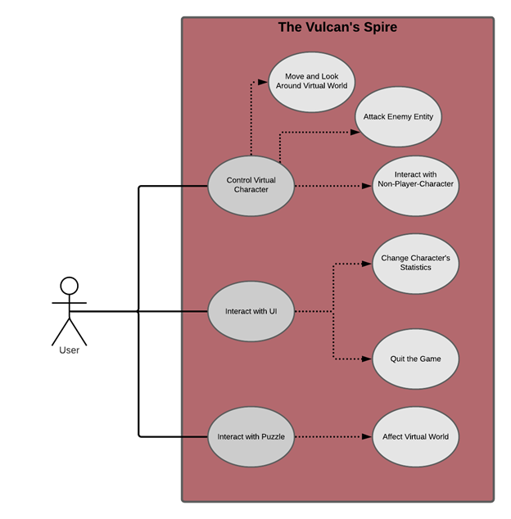

**Description:**

1. *Control Virtual Character:*

* *Move and Look around Virtual World:* The user can walk around in a virtual 3D environment.
* *Attack Enemy Entity:* The user may attack enemy characters using an equipped weapon.
* *Interact with Non-Player-Character:* The user may prompt an NPC for dialogue.

2. *Interact with UI:*

* *Change Character’s Statistics:* The user may select different UI items to alter the way they do things.
* *Quit the Game:* The user may quit out of the game at any time.

3. *Interact with Puzzle:*

* *Affect Virtual World:* Completing a puzzle can affect the virtual world allowing the user to move forward in progression.

# Initial Requirements

## Functional

Vulcan’s Spire will have keyboard and mouse input for PC and touchscreen input for mobile devices. Users will control a virtual character and be able to interact with the game environment. This includes objects, non-playable characters, puzzles, etc. Users will manage their characters through a user interface. This will allow them to change game settings and adjust elements of the player character such as items or equipment.

## Non-functional

The game will be runnable on Windows, Android, and iOS. As with most games, Vulcan’s Spire will attempt to minimize game loading times to improve overall playability. It will utilize 3D assets made in Blender and pre-fabricated assets found on the Unity Asset Store. The game will feature a simple and easy-to-read HUD (Heads-up display)/UI (user-interface) elements. Code will also have to be written and reformatted in a way to improve response times and reduce lag time. One implementation is a built-in system that Unity uses called “prefabs”. These are assets that allow game objects to be saved for re-use whether it be through cloning or at runtime. These help to improve the workflow of the game’s creation and aid in the performance of the actual game.

## Documentation

Internal documentation will be kept and used for the implementation phase of the game. The documentation to be utilized will include:

* + Requirements - Used for describing goals and general specifications for the game
  + Specifications - Used for describing the game in more detail
  + Design - Used for describing what elements of the game should be implemented in detail and how they should be implemented
  + Peer Evaluations – Used for describing the tasks each group member is assigned to do and to keep track of development progress

External documentation will also be kept for the user to reference when needed. This will include a game manual to describe how to play the game, the elements that are in the game, and a version log that describes any changes, fixes, and known bugs.

# Testing/Revisions

Each group member was assigned a section of the document to write in their own time. Every team member then proofread the entire document and made any revisions as necessary. For ease of access to the latest version of the document, we made a Microsoft Live document to collaborate. We used the voice/messaging platform Discord to further collaborate through text inquiries, voice meetings, and the sharing of documents and resources. Outside of formatting and any additional information supplementing the content already provided here, no major revisions have been made to the document.

# List of References

Disalvo, B. J., & Bruckman, A. (2009, April). *Questioning Video Games' Interest on CS Interest.* Retrieved from ResearchGate: https://www.researchgate.net/publication/220795048_Questioning_video_games'_influence_on_CS_interest

Reisinger, Don. (2011, October). *91 Percent of Kids are Gamers, Research Says.* Retrieved from: Cnet.com <https://www.cnet.com/home/smart-home/91-percent-of-kids-are-gamers-research-says/>

# Appendix: Technical Glossary

**HUD** – Heads-up display (i.e. health points)

**UI** – User interface (i.e. user inputs/hotkeys)

**Vulcan’s Spire** – The name and current title of the project

**C#** - The coding language that will be used for the game

**NPC** – Non-playable character

**Discord** – VoIP, instant messaging, and digital distribution platform

# Appendix: Team Details (workflow leader and description of each team member's contributions)

The workflow leader is Nicholas Spudich. The document was divided into sections for each team member to complete. Any member who had questions or concerns voiced them using Discord. Each member checked-in upon completion to give summary of their contributions. This ensured a deeper and clearer understanding of the work to be performed. Upon completion of this document, each member read through and gave their “okay” for the document to be pushed forward to the writing center and submitted.

# Appendix: Workflow Authentication (individual dated signatures on testament statement)

I, Nicholas Spudich, hereby confirm that I have contributed to the information outlined in this document.

Signature:________________________________________________________________________

Date:__________________________

I, Andrew Spate, hereby confirm that I have contributed to the information outlined in this document.

Signature:________________________________________________________________________

Date:__________________________

I, Kevin Andor, hereby confirm that I have contributed to the information outlined in this document.

Signature:________________________________________________________________________

Date:__________________________

I, Nathaniel DeHart, hereby confirm that I have contributed to the information outlined in this document.

Signature:________________________________________________________________________

Date:__________________________

# Appendix: Report from the Writing Center

Included in a separate document.